**Documentation for Mars Rover Replica**

1. **Solidworks Design of Rover**

The model for the rover was downloaded from howtomechatronics.

This model had a lot of extra accessories which were not useful for the application. Also the chassis was a little smaller than desired and all the parts were scaled by 1.25 times. To improve the strength of the joint in the C joint the part was redesigned to be a single part instead of 2 parts. In order to enhance the secure fastening of the motors within the part, precise diameter measurements were implemented, and a nut was incorporated onto the motor. As a result, only the motor shaft protrudes through the hole in the part, and the nut is utilized to firmly secure it in place.

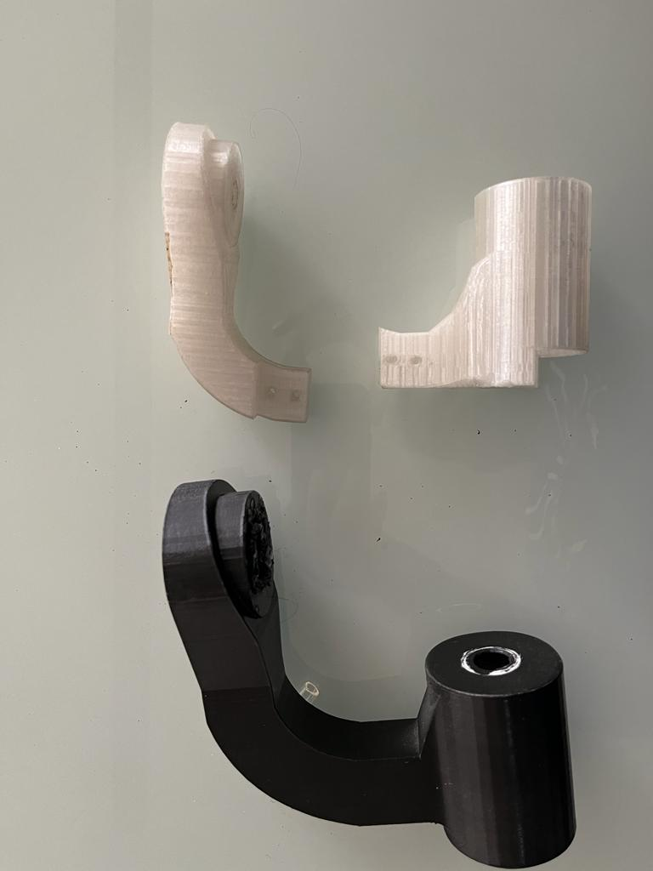

**Fig 1. Old Joints Vs New Joints**

To cover the rover, sheets were designed. The sheets were then CNC cut using acrylic material.

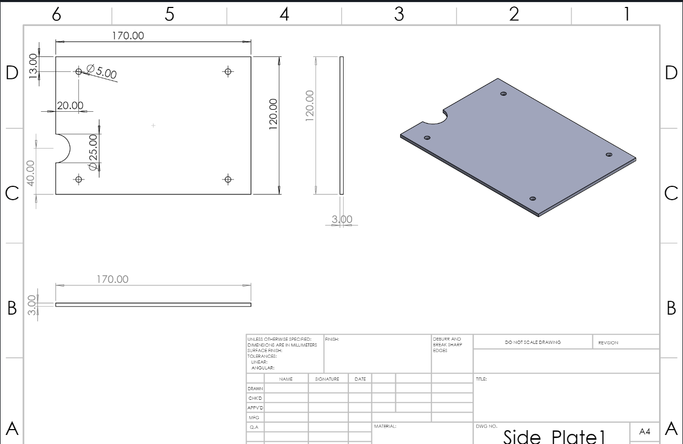

**Fig 2. Plate drawings**

Upon examination using SolidWorks assembly, it was discovered that the pipe lengths were inaccurately measured. Fig 3 clearly illustrates that all three pipe lengths are misaligned. To rectify this issue, the pipe lengths were recalculated using formulas and also verified using the SolidWorks assembly. By comparing the results obtained from both methods, the final and correct pipe lengths were determined.

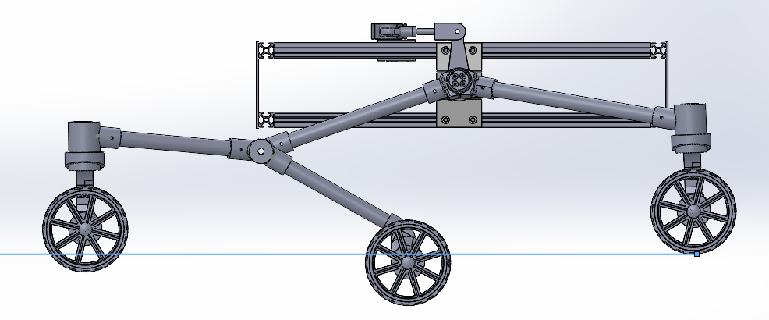

**Fig 3. Wheel Misalignment**

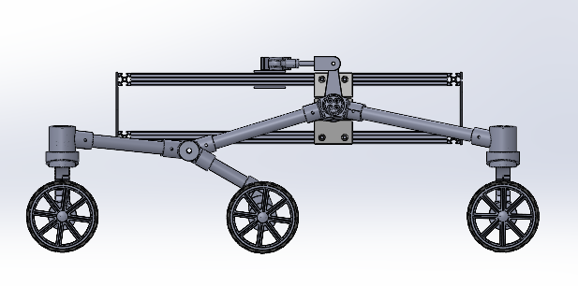

**Fig 4. Rover after correction of pipe lengths**

**Table I: Pipe Length Calculation**

| **Pipe Number** | **Old assembly Measured (mm)** | **Calculated through formulae (mm)** | **Solidworks Assembly (mm)** |
| --- | --- | --- | --- |
| 1 | 200 | 160.8 | 170.89 |
| 2 | 200 | 130.66 | 123.36 |
| 3 | 240 | 200 | 200 |
| 4 | 275 | 230 | 236 |

After making all these changes to individual part files a final assembly was created which can be seen in Fig 5 and 6.

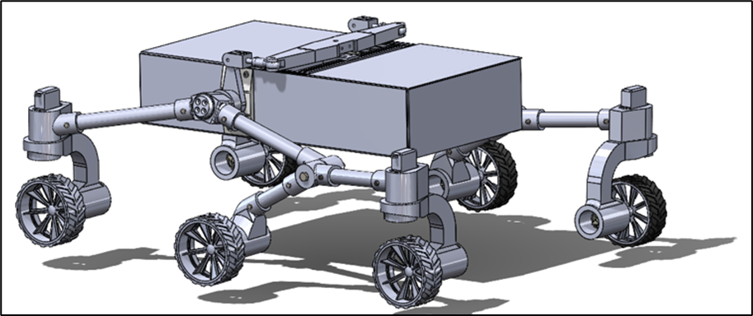

**Fig 5. Complete Assembly**

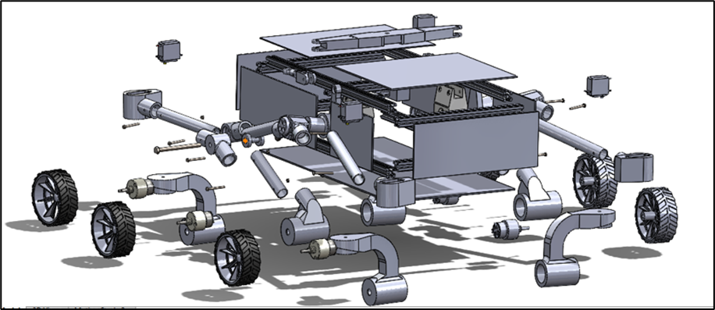

**Fig 6. Exploded view of assembly showing individual parts**

1. **Ansys Analysis**

In order to determine the load carrying capacity of the rover, a static structural analysis was performed using Ansys workbench. The process involves material assignment, mesh generation, force and support assignment and necessary boundary conditions. After successfully solving the model results on deformation, stress and strain were obtained.

**Material Assignment:** In Ansys, the materials designated for constructing the rover were assigned based on their specific properties and intended use. The chosen materials were **Aluminum Alloy, Acrylic, Polylactic acid (PLA), PVC and Structural Steel.**

For the chassis, sturdy Aluminum Alloy was selected and built using T-Slot Aluminum profiles of 20×20 mm to ensure durability and stability. The rover body was constructed using Acrylic, which was covered with 2 mm thick acrylic sheets to provide a robust yet lightweight structure. PVC piping was utilized to connect the 3D printed joints. PLA was assigned to 3D printed parts. Lastly, Structural Steel was used for screws, nuts, bolts, and bearings, ensuring that the components remain firmly in place and function effectively.

**Table II: Material Information**

| **MATERIALS** | **Young's Modulus (GPa)** | **Maximum Deformation (%)** | **Maximum Stress (MPa)** |
| --- | --- | --- | --- |
| PVC (Poly Vinyl Chloride) | 3.5 | 20 | 25 |
| PLA (Polylactic Acid) | 3.1 | 5 | 40 |
| Aluminum | 70 | 25 | 345 |
| Steel | 200 | 15 | 690 |

By utilizing these materials, we were able to construct a well-designed and functional rover, with each component serving a specific purpose in the overall structure.

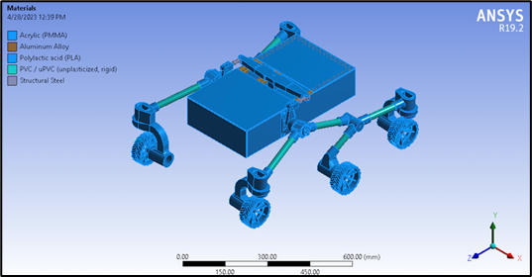

**Fig 7. Material Assignment in Ansys**

**Mesh Generation:** A mesh size of 8 mm was employed to create the mesh, resulting in 1,567,960 nodes and 405,045 elements. The image 7 illustrates the mesh statistics.

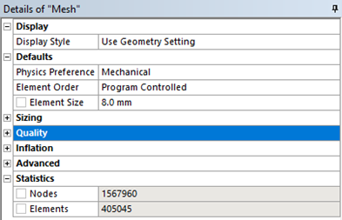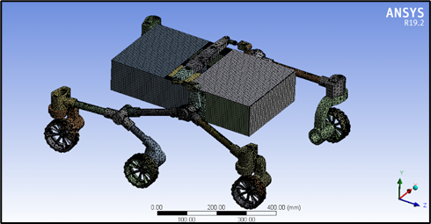

**Fig 8(a): Mesh Statistics Fig 8(b): Mesh applied to assembly**

**Boundary Conditions:** To conduct a static structural analysis, the wheels of the rover were fixed in place, simulating their resting position on the ground. A load of 40 Newtons was applied to the bottom plate of the rover to represent the weight it would carry. Additionally, the standard gravity of the earth was considered during the analysis to account for the load exerted by the weight of the rover itself.

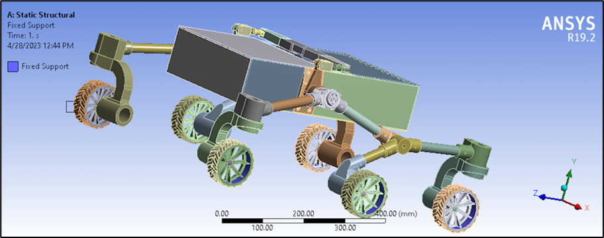

**Fig 9: Fixed Support Assignment**

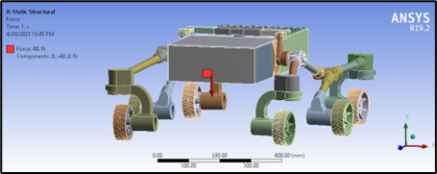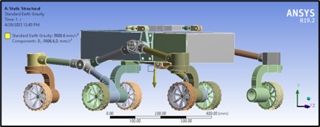

**Fig 9(b): Assigning Load to rover Fig 9(c): Standard Earth Gravity**

1. **Results**

ANSYS static structural analysis results provided valuable insights into deformation behavior, elastic strain and load distribution within a structure.The analysis shows the maximum load bearing point for each part. The total model analysis was used to check for structural integrity and also check the load bearing capacity of the rover.

**Deformation:**

Based on the analysis results, it is evident that the maximum deformation occurs on the bottom plate of the rover, which serves as the designated space for housing the electronics. The weight attributed to the electronics amounts to approximately 400 grams. This deformation assessment was performed under the assumption of a total load of 4 KGs on the rover.

Notably, the maximum deformation is found to be approximately 1.45 mm, which is deemed minimal and falls within the safety allowable range. This indicates that the bottom plate can adequately support the load without experiencing significant structural compromise.

These findings affirm the structural integrity and suitability of the bottom plate for its intended purpose, providing assurance that the rover can effectively carry the required equipment and operate within the desired agricultural field conditions.

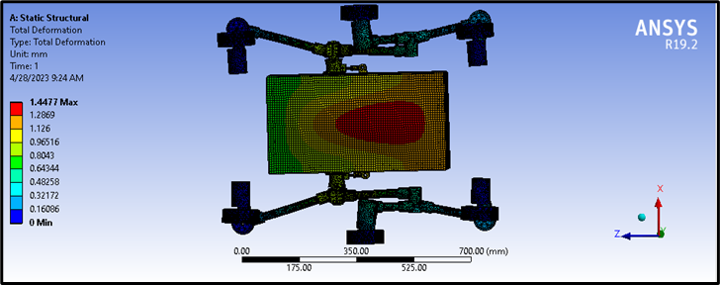

**Fig 10:Max deformation in Rover**

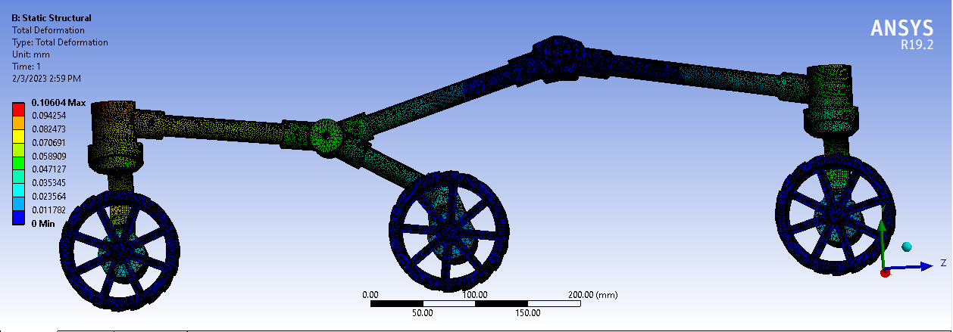

**Fig 11: Maximum deformation in wheel assembly**

**Equivalent Elastic Strain:**

Elastic strain refers to the temporary deformation that a material undergoes when subjected to external forces, but it can return to its original shape and size once the forces are removed. It is a reversible deformation that occurs within the elastic limit of the material, meaning that the material will not experience permanent or plastic deformation.

In our study, we found that the PVC pipes used for connecting joints in the rover experienced a maximum elastic strain of approximately 3.77×10-3. This indicates that the PVC pipes underwent a temporary deformation by a very small amount which is certainly negligible when subjected to external forces.

The maximum elastic strain in the rover was observed in the PVC pipes that were used for connecting different joints in the rover. The maximum strain value accounted for around 3.77×10-3.

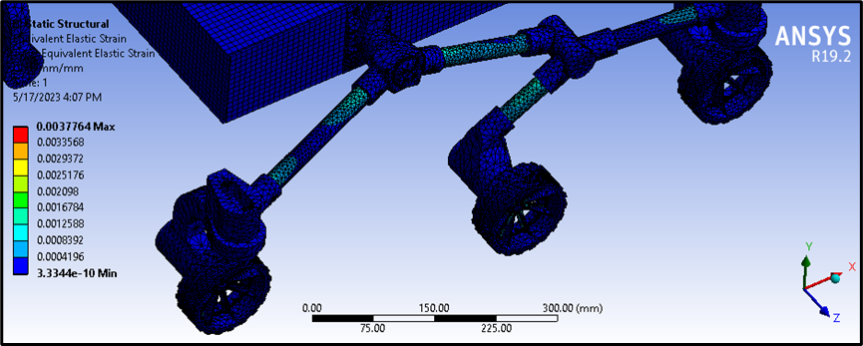

**Fig 12. Max elastic strain in rover**

1. **Fabrication of Rover**After testing the model design using simulations, the physical fabrication of the rover commenced. The body of the rover was constructed using 20mm T-slot aluminum profiles, which were cut to the required length and joined together using hammer nuts and bolts. The frame was then covered with acrylic sheets, providing a protective layer for the rover's internal components.

All necessary joint parts were produced using 3D printing, utilizing PLA material. In addition, PVC pipes were cut to specified lengths, determined by a predetermined formula and with the assistance of solidworks for the bogie rocker joint. Once the parts were verified, they were assembled to ensure the wheelbase was balanced and functional.

This fabrication process ensured the rover's structural integrity and ability to withstand the rigors of its intended agricultural environment. The utilization of high-quality materials and precision engineering techniques resulted in a robust and reliable rover design, capable of effectively carrying out its intended functions.

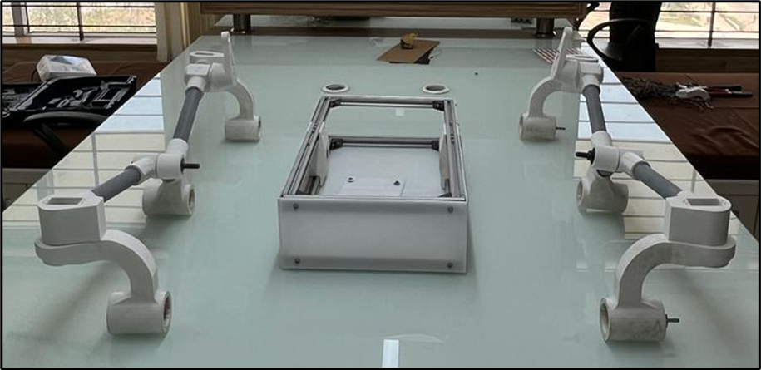

**Fig 13. Hardware Overview**

Once the wheelbase was fabricated, it underwent a finishing process where it was coated with black paint to enhance its aesthetic appearance.

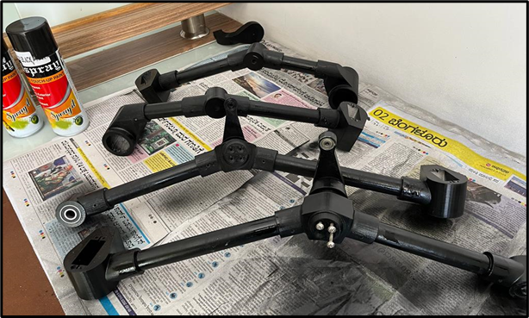

**Fig 14. Black Paint Coating**

The wheels utilized in the rover are pre-manufactured and can be easily coupled with the DC motor shaft. Turning of the wheels is accomplished by using servo motors that were connected to the C joints via a servo disc and servo coupler. The servo coupler included a nut that rotates around a locknut, and when the servo rotates, the entire component moves in tandem, enabling precise control of the wheels' direction.

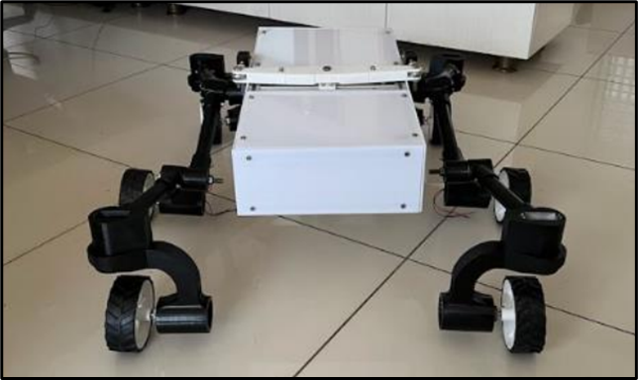

**Fig. 14 Complete Mechanical Assembly**

1. **Electrical Overview**

The Arduino Mega served as the central controlling system for the Mars Perseverance Rover replica. To move the rover forward and backward, three L298N controllers are utilized to control six 500 RPM 12V DC motors that are connected to the wheels. All of this is powered using a 12V LiPo battery.

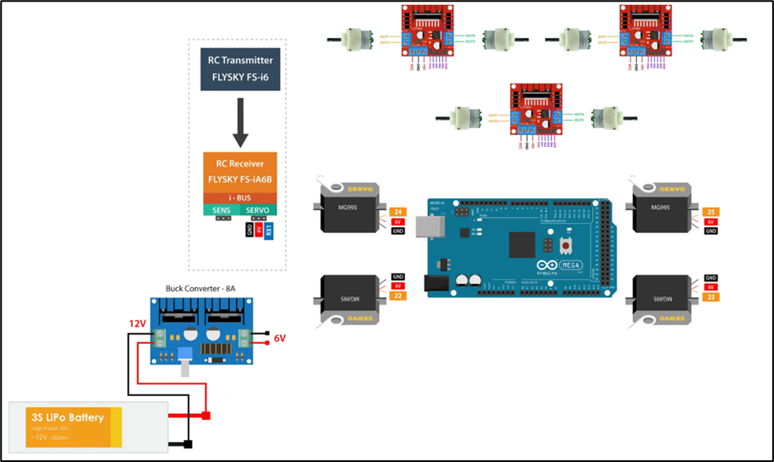

**Fig 15. Circuit Diagram**

To achieve wheel rotation, the plan was to utilize MG996R servo motors. These servo motors need 6V, 2A each. A basic buck converter can only provide 1A of current. For this project a 10A buck converter was used which could supply 2A of current to all the motors. However, it was discovered that these particular servo motors lack a potentiometer, making it challenging to control them to a precise angle. As an alternative solution, the MG995 servo motors, which do have a potentiometer, were examined and utilized instead. These motors possess a holding torque of 10N-m. However, due to this constraint, the C joints cannot be fully tightened, resulting in the wheels flexing or bending during motion. As a result, by fully tightening the C joints, the rover's DC motors enable the rotation of the rover by turning one set of wheels in reverse while the other set of wheels moves forward.

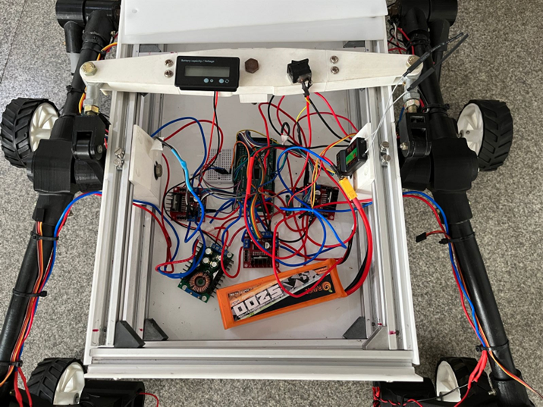

**Fig 16. Electrical Overview of Rover**

1. **Future Scope**

A further change can be made to the rover by:

1. **Aluminium pipes:** The PVC pipes exhibit flexibility, leading to bending of the wheels. Additionally, the screws used to attach the pipes to the joints are made of steel, causing the holes in the plastic pipes to enlarge over time. To resolve these issues, one possible solution is to replace the PVC pipes with aluminum pipes. This substitution would enhance structural integrity and provide a stronger grip for the screws, resulting in improved overall performance.
2. **C joint new design:** To enable turning using servo motors, a new C joint design has been developed. This design directly connects the C joint to the servo motor, eliminating the need for a nut and a locking nut. By doing so, the issue of tightening is effectively addressed and resolved.
3. **Stronger Servo Motors:** The MG995 servo motor has a torque rating of 10N-m. However, it has been observed that the ones used in the howtomechatronics project have a higher torque rating of 25N-m. To address the tightening issue of the C joint, it is recommended to consider purchasing servo motors with the higher torque rating in order to provide a stronger and more secure tightening mechanism.

**7. References:**

1. *Naik, Nithesh, et al. "Design and analysis of ugv with Rocker bogie mechanism for landmine Extraction." aInternational Journal of Mechanical Engineering and Technology 10.1 (2019): 1731-1744.*
2. *Verma, Abhisek, et al. "Design of Rocker-Bogie Mechanism." International Journal of Innovative Science and Research Technology 2.5 (2017).*
3. *Chinchkar, Dhananjay, et al. "Design of rocker bogie mechanism." International Advanced Research Journal in Science, Engineering and Technology 4.1 (2017): 46-50.*
4. *Saraiya, Para Bimal. "Design of Rocker Bogie Mechanism." International Research Journal of Engineering and Technology (IRJET) (2020).*
5. *Dejan. “DIY Mars Perseverance Rover Replica - Arduino Based Project.” How to Mechatronics, 3 June 2021, howtomechatronics.com/projects/diy-mars-perseverance-rover-replica-with-arduino.*
6. *mars.nasa.gov. “Mars 2020 Perseverance Rover - NASA.” Mars 2020 Perseverance Rover - NASA Mars, 18 May 2023, mars.nasa.gov/mars2020.*
7. *“L298N Motor Driver Module.” Components101, components101.com/modules/l293n-motor-driver-module.*
8. *Shenoy, Pradeep S., et al. "Comparison of a 12V, 10A, 3MHz buck converter and a series capacitor buck converter." 2015 IEEE Applied Power Electronics Conference and Exposition (APEC). IEEE, 2015.*
9. *“How to Make 6 Channel Radio Control for Models. Diy Proportional RC – RC Models, DIY Hobby Elektronics, Arduino Projects, RC Airplanes.” How to Make 6 Channel Radio Control for Models. Diy Proportional RC – RC Models, DIY Hobby Elektronics, Arduino Projects, RC Airplanes, 9 Apr. 2020, www.rcpano.net/2020/04/09/how-to-make-6-channel-radio-control-for-models-diy-proportional-rc.*
10. *Senthilnathan, K., et al. "Design and analysis of gear testing kit and static structural analysis of spur gear using ANSYS software." IOP Conference Series: Materials Science and Engineering. Vol. 988. No. 1. IOP Publishing, 2020.*